HYBRID INFORMATION MIXING MODULE FOR STOCK MOVEMENT PREDICTION
AN INDUSTRIAL ORIENTED MINI PROJECT REPORT
Submitted
in the partial fulfillment of the requirements for the award of the degree of
BACHELOR OF TECHNOLOGY
in
COMPUTER SCIENCE AND ENGINEERING
by
S. AMRUTHA - 23B81A05K7
N. VISHWAS - 23B81A05R2
K. Sri Karan Reddy – 23B81A05P9
Under the guidance of
Mr N Srinu
Assistant Professor, Dept. of CSE

DEPARTMENT OF COMPUTER SCIENCE AND ENGINEERING
CVR COLLEGE OF ENGINEERING
(An Autonomous institution, NBA, NAAC Accredited and Affiliated to JNTUH, Hyderabad)
Vastunagar, Mangalpalli (V), Ibrahimpatnam (M),
Rangareddy (D), Telangana- 501 510

April 206

CVR COLLEGE OF ENGINEERING
(An UGC Autonomous Institution with NAAC ‘A’ Grade,Affiliated to JNTUH)
Vastunagar, Mangalpalli (V), Ibrahimpatan (M), R.R.District, Telangana

DEPARTMENT OF COMPUTER SCIENCE AND ENGINEERING

CERTIFICATE

This is to certify that the Industrial Oriented Mini project entitled "HYBRID INFORMATION MIXING MODULE FOR STOCK MOVEMENT PREDICTION" being submitted by S. AMRUTHA (23B81A05K7), K. SRI KARAN REDDY (23B81A05P9), N. VISHWAS (23B81A05R2) in partial fulfillment for the award of Bachelor of Technology in Computer Science and Engineering to the CVR College of Engineering, is a record of bona fide work carried out by them under my guidance and supervision during the year 2025-2026.

The results embodied in this Industrial Oriented Mini project work have not been submitted to any other University or Institute for the award of any degree or diploma.

Signature of the project guide Signature of the HOD

Mr. N. Srinu Dr. A Vani Vathsala
Assistant Proffesor-CSE Department of CSE

External Examiner

DECLARATION

We hereby declare that the Industry Oriented Mini Project report entitled "Hybrid Information Mixing Module for Stock Movement Prediction" is an original work done and submitted to CSE Department, CVR College of Engineering, affiliated to Jawaharlal Nehru Technological University Hyderabad in partial fulfilment for the requirement of the award of Bachelor of Technology in Computer Science and Engineering and it is a record of bonafide project work carried out by us under the guidance of Mr. N. Srinu, Associate Professor, Department of CSE.

We further declare that the work reported in this project has not been submitted, either in part or in full, for the award of any other degree in this Institute or any other Institute or University.

Signature of the Student S. AMRUTHA | Signature of the Student K. SRI KARAN REDDY
Signature of the Student N. VISHWAS | Date: Place: Hyderabad

ACKNOWLEDGEMENT

The satisfaction that accompanies the successful completion of any task would be incomplete without the mention of the people who made it possible and whose encouragement and guidance has been a source of inspiration throughout the course of the project.
It is a great pleasure to convey our profound sense of gratitude to our principal Dr. K.Rama Mohan Reddy, Vice-Principal Prof. L. C. Siva Reddy, Dr. A. Vani Vathsala, Head of CSE Department, CVR College of Engineering, for having been kind enough to arrange necessary facilities for executing the project in the college.
We deem it a pleasure to acknowledge our sense of gratitude to our project guide Assistant Professor.Mr.N.Srinu under whom we have carried out the project work. Her incisive and objective guidance and timely advice encouraged us with constant flow of energy to continue the work.
We wish to express a deep sense of gratitude and heartfelt thanks to the management for providing excellent lab facilities and tools. Finally, we thank all those whose guidance helped us in this regard.
We place highest regards to our Parents, our Friends and Well-wishers who helped a lot in making this project report.

S. AMRUTHA (23B81A05K7)
K. SRI KARAN REDDY (23B81A05P9)
N. VISHWAS (23B81A05R2)

ABSTRACT

HYBRID INFORMATION MIXING MODULE FOR STOCK MOVEMENT
PREDICTION

Stock market prediction is a challenging task due to the highly volatile and dynamic nature of financial markets. Stock prices are influenced by multiple factors such as historical price trends, market indicators, and unstructured textual information including financial news and social media. Traditional stock movement prediction systems mainly rely on technical analysis using historical price data or sentiment analysis using text data. However, these approaches often fail to capture the complex relationship between numerical and textual market information, resulting in limited prediction accuracy.

In the previous system, stock movement prediction was performed using single-source models such as ARIMA, LSTM, or GRU for time-series price data and sentiment-based models for analyzing news or social media data. Some systems combined price and text data using simple feature concatenation or attention mechanisms. These methods suffered from issues such as information loss, weak feature interaction, and high computational complexity, which limited their effectiveness in highly volatile market conditions.

To overcome these limitations, this project proposes a Hybrid Information Mixing Module for Stock Movement Prediction. The proposed system uses a two-stage feature learning approach. In the first stage, time-series features are extracted from historical stock prices using Gated Recurrent Units (GRU), while semantic features are extracted from financial text using Bidirectional Encoder Representations from Transformers (BERT). In the second stage, both features are combined into a fixed-dimensional mixed feature and processed through a hybrid information mixing module consisting of feature-mixing and interaction-mixing multilayer perceptrons (MLPs). This architecture enables effective interaction between numerical and textual information.

TABLE OF CONTENTS

Chapter No. | Contents | Page No.
 | Abstract | v
 | List of Tables | viii
 | List of Figures | ix
 | Abbreviations | x
1 | INTRODUCTION | 1
1.1 | Motivation | 1
1.2 | Problem Statement | 2
1.3 | Project Objectives | 2
1.4 | Project Report Organization | 3
2 | LITERATURE SURVEY | 5
2.1 | Existing Work | 5
2.2 | Limitations of Existing Work | 7
3 | SOFTWARE AND HARDWARE SPECIFICATIONS | 9
3.1 | Software Requirements | 9
3.1.1 | Functional Requirements | 9
3.1.2 | Non-Functional Requirements | 10
3.2 | Hardware Requirements | 11
4 | PROPOSED SYSTEM DESIGN | 13
4.1 | Proposed Methodology | 13
4.1.1 | Feature Embedding | 14
4.1.2 | Hybrid Information Mixing Module | 14
4.1.3 | Binary Classifier | 14
4.2 | Use Case Diagram | 15
4.3 | Activity Diagram | 16
4.4 | Sequence Diagram | 17
4.5 | Class Diagram | 18
4.6 | Deployment Diagram | 19
4.7 | System Architecture | 20
4.8 | Technology Description | 21
5 | IMPLEMENTATION | 22
5.1 | Dataset | 22
5.2 | Training Setup | 22
5.3 | GRU-based Price Embedding Module | 23
5.4 | BERT-based Text Embedding Module | 23
5.5 | Mixed Feature Construction | 24
5.6 | Feature-Mixing MLP | 24
5.7 | Interaction-Mixing MLP | 24
5.8 | Binary Classifier and Loss Function | 25
5.9 | Screenshots | 25
6 | TESTING | 27
6.1 | Evaluation Metrics | 27
6.2 | Results of Stock Movement Prediction | 27
6.3 | Ablation Study | 28
7 | CONCLUSION AND FUTURE SCOPE | 30
7.1 | Conclusion | 30
7.2 | Future Scope | 30
 | REFERENCES | 32

LIST OF TABLES

Table No. | Title | Page No.
1.3.1 | Summary of Project Objectives | 3
2.1.1 | Literature Survey Summary | 6
2.2.1 | Limitations of Existing Systems | 7
3.1.1 | Software Tools and Technologies Used | 10
3.2.1 | Minimum Hardware Requirements | 11
3.2.2 | Recommended Hardware Configuration | 12
5.2.1 | Training Hyperparameters | 22
6.2.1 | Comparison of Information Mixing Methods | 28
6.3.1 | Comparison of Price Embedding Methods | 29

LIST OF FIGURES

Figure No. | Title | Page No.
4.1.1 | Overall Architecture of Hybrid Information Mixing Module | 13
4.2.1 | Use Case Diagram | 15
4.3.1 | Activity Diagram | 16
4.4.1 | Sequence Diagram | 17
4.5.1 | Class Diagram | 18
4.6.1 | Deployment Diagram | 19
4.7.1 | System Architecture Diagram | 20
5.9.1 | Home Page | 25
5.9.2 | Prediction Page | 26

ABBREVIATIONS

Abbreviation | Full Form
ARIMA | Autoregressive Integrated Moving Average
BERT | Bidirectional Encoder Representations from Transformers
BCE | Binary Cross-Entropy
CNN | Convolutional Neural Network
DL | Deep Learning
F1 | F1 Score (Harmonic Mean of Precision and Recall)
GAP | Global Average Pooling
GELU | Gaussian Error Linear Unit
GRU | Gated Recurrent Units
LSTM | Long Short-Term Memory
MCC | Matthews Correlation Coefficient
MLP | Multilayer Perceptron
NLP | Natural Language Processing
NYSE | New York Stock Exchange
RNN | Recurrent Neural Network
S&P | Standard and Poor's
NASDAQ | National Association of Securities Dealers Automated Quotations

CHAPTER 1

INTRODUCTION
In the modern financial landscape, accurately predicting stock price movement is one of the most challenging and commercially significant tasks in artificial intelligence and machine learning. Stock markets are highly volatile and influenced by a multitude of factors, including historical price patterns, trading volumes, and unstructured information from financial news, earnings reports, and social media platforms such as Twitter. The ability to forecast whether a stock price will rise or fall on a given trading day can provide a significant advantage to investors, traders, and automated trading systems.

This project proposes a Hybrid Information Mixing Module (HIMM) for stock movement prediction that addresses this limitation by combining time-series price features extracted using Gated Recurrent Units (GRU) with semantic features extracted from financial tweets using Bidirectional Encoder Representations from Transformers (BERT). The extracted features are fused into a mixed feature representation and processed through two MLP-based mixing blocks that enable effective multimodal interaction for accurate binary stock movement classification.

1.1 MOTIVATION
The motivation for developing the Hybrid Information Mixing Module arises from the persistent inadequacy of single-source models in capturing the complex dynamics of stock markets. The key motivating factors include:
- Stock markets are affected by both numerical price trends and qualitative information from news and social media, making multimodal approaches essential.
- Existing models such as LSTM and GRU focus only on historical price data, missing the semantic signals that often precede price movements.
- Transformer-based multimodal models are computationally expensive and structurally complex, making them difficult to deploy in real-time trading environments.
- A simpler MLP-based architecture that effectively mixes multimodal information can achieve comparable or superior performance with lower computational overhead.
- The StockNet dataset, comprising S&P 500 price data and Twitter posts, provides a rich real-world benchmark for evaluating multimodal stock prediction models.

1.2 PROBLEM STATEMENT
Stock markets are highly volatile and influenced by both numerical price data and unstructured textual information such as financial news and social media posts. Existing prediction systems either focus only on historical price data or process textual data independently, which limits their ability to capture the complex interaction between different data sources. Simple feature concatenation approaches suffer from information loss and weak feature interaction, while transformer-based multimodal models impose high computational complexity. This results in reduced prediction accuracy and unreliable forecasting.

Hence, there is a need for an efficient system that can integrate and analyze multimodal market information — combining time-series price signals and textual sentiment signals — through an effective mixing mechanism to accurately predict stock price movement.

1.3 PROJECT OBJECTIVES
The primary objective of this project is to design and implement a Hybrid Information Mixing Module that effectively combines numerical and textual market features for accurate stock movement prediction.

Table 1.3.1: Summary of Project Objectives

Obj. No. | Project Objective Description
1 | To extract time-series features from historical stock price data using GRU.
2 | To extract semantic features from financial Twitter data using BERT.
3 | To create a mixed feature by concatenating price and text features.
4 | To design a Feature-Mixing MLP that enables communication between different tokens.
5 | To design an Interaction-Mixing MLP that enables communication between different channels.
6 | To evaluate the model on the StockNet dataset using accuracy, F1-score, and MCC metrics.

1.4 PROJECT REPORT ORGANIZATION
Chapter 1 : Introduction
This chapter presents an overview of the stock movement prediction system, including the motivation, problem statement, and objectives. It explains the challenges of predicting stock prices due to market volatility and highlights the need for integrating both historical price data and financial news.
Chapter 2 : Literature Survey
This chapter reviews existing stock prediction methods such as ARIMA, LSTM, and GRU, along with NLP-based approaches like sentiment analysis using BERT. It discusses their working mechanisms, advantages, and limitations, particularly their inability to effectively combine numerical and textual data.
Chapter 3 : Software & Hardware Specifications
This chapter describes the requirements for implementing the system. It includes software tools such as Python, TensorFlow/PyTorch, NumPy, Pandas, and Transformers.

Chapter 4 : Proposed System Design
This chapter explains the architecture and workflow of the proposed system. It describes data collection, preprocessing, feature extraction using GRU for time-series data and BERT for textual data, and their integration using the Hybrid Information Mixing Module (HIMM).
Chapter 5 : Implementation and Testing
This chapter details the implementation of the system, including data preprocessing, model building, training, and prediction. It also explains testing methodologies and evaluates performance using metrics such as Accuracy, F1-Score, and MCC to validate the effectiveness of the model.
Chapter 6 : Conclusion and Future Scope
This chapter summarizes the outcomes of the project and confirms that the hybrid approach improves prediction accuracy.
Chapter 7 : References
This section lists all the research papers, articles, and online resources used during the project in a standard format.

CHAPTER 2

LITERATURE SURVEY
Research on stock price movement prediction using deep learning has been actively conducted in the financial industry. This chapter presents an overview of existing research in the domain of stock movement prediction, covering technical analysis approaches, fundamental analysis methods, and multimodal systems. The survey identifies key limitations in existing work that motivated the design of the Hybrid Information Mixing Module.

2.1 EXISTING WORK
Zhang et al. proposed a state-frequency memory regression network based on the RNN model to capture multi-frequency trading patterns from historical price data for stock price prediction trends. While effective for capturing periodic patterns, this approach relies solely on numerical price data and cannot incorporate semantic signals from news or social media.

Xu and Cohen proposed Stock Net, a method to encode the temporal trend in historical prices using GRU and combine it with tweet-based sentiment for stock movement prediction. This foundational work introduced the Stock Net dataset and demonstrated the value of combining price and text data, but used relatively simple feature fusion without deep interaction between modalities.

Sawhney et al. proposed a deep attentive learning method for stock movement prediction from social media text and company correlations using a hierarchical graph attention network. While this method captures inter-company relationships, it relies on complex graph-based architectures that are computationally expensive.

Zhao et al. designed the Dual-Attention Network Stock Movement Prediction (DANSMP) based on a comprehensive market knowledge graph including company executives and hybrid relations. This method captures rich relational knowledge but requires the construction and maintenance of a complex knowledge graph.

Table 2.1.1: Literature Survey Summary

S.No | Author(s) | Title | Year | Venue | Challenges Found
1 | Zhang et al. | State-Frequency Memory RNN | 2017 | ACM SIGKDD | Only uses price data; cannot capture text signals
2 | Xu & Cohen | Stock Net (GRU + Tweets) | 2018 | ACL | Simple fusion; weak feature interaction between modalities
3 | Sawhney et al. | Hierarchical Graph Attention | 2020 | EMNLP | Complex graph construction; high computational cost
4 | Zhao et al. | DANSMP (Knowledge Graph) | 2022 | arXiv | Requires knowledge graph maintenance; limited scalability
5 | Yoo et al. | Data-Axis Transformer | 2021 | ACM SIGKDD | Transformer complexity; not optimized for simple deployment
6 | Choi et al. | Hybrid Information Mixing Module | 2023 | IEEE Access | Baseline for this project; proposed approach

2.2 LIMITATIONS OF EXISTING WORK
An analysis of the existing literature reveals several consistent gaps that current systems fail to address. These limitations are systematically captured in the table below and serve as the direct motivation for the design choices made in this project.

Table 2.2.1: Limitations of Existing Systems

System/Study | Key Feature | Major Limitation
ARIMA / Statistical Models | Historical price forecasting | Cannot model non-linear patterns; ignores text data
LSTM / GRU (price only) | Time-series price modeling | No semantic signal; misses news-driven price movements
Sentiment Analysis Models | Text sentiment classification | Ignores price patterns; no temporal modeling
Stock Net (Xu & Cohen) | Price + tweet combination | Simple concatenation; weak cross-modal interaction
Graph Attention Networks | Inter-company correlations | Complex architecture; expensive graph construction
Transformer-based Models | Attention-based multimodal fusion | High computational complexity; slow inference

Drawbacks of Existing System
- Most traditional models rely only on historical price data and ignore external factors influencing the market.
  - Limited ability to capture the impact of financial news, market sentiment, and global events.
  - Time-series models like ARIMA, LSTM, and GRU fail to handle complex nonlinear relationships effectively.
  - Sentiment analysis models focus only on textual data and ignore numerical price trends.
  - Existing approaches use simple feature fusion techniques, leading to weak interaction between features.
  - Information loss occurs during the integration of numerical and textual data.
  - High computational complexity in advanced models, making them inefficient for real-time prediction.
  - Poor scalability when handling large volumes of financial and textual data simultaneously.
  - Lack of a robust and unified framework for effective multimodal data integration.

CHAPTER 3

SOFTWARE AND HARDWARE SPECIFICATIONS
This chapter provides an in-depth description of the software and hardware specifications required for the implementation of the Hybrid Information Mixing Module. These specifications ensure that the system is developed in an optimized environment to deliver consistent performance, reliability, and reproducibility.

3.1 SOFTWARE REQUIREMENTS
The system is developed in Python using deep learning libraries PyTorch and TensorFlow. Pre-trained BERT models are accessed via the HuggingFace Transformers library. GRU-based price encoding is implemented using PyTorch RNN modules. The Stock Net dataset is used for training and evaluation.

3.1.1 Functional Requirements
- Collection and preprocessing of historical stock price data (open, high, low, close prices, and trading volume) for S&P 500 companies.
- Collection and preprocessing of financial Twitter data associated with each company using NASDAQ ticker symbols.
- Time-series feature extraction from historical price data using a GRU-based price embedding model.
- Semantic feature extraction from Twitter data using a pre-trained BERT model with contextual word embeddings.
- Feature fusion through concatenation to create a fixed-dimensional mixed feature matrix.
- Feature-Mixing MLP that operates on the transposed mixed feature to mix channel information across tokens.
- Interaction-Mixing MLP that operates on each row of the mixed feature to mix embedding vectors across channels.
- Binary classification of stock price movement (up/down) using a global average pooling layer and fully connected output layer.
- Performance evaluation using accuracy, precision, recall, specificity, F1 score, and Matthews Correlation Coefficient (MCC).

3.1.2 Non-Functional Requirements
- Accuracy: The system must achieve higher prediction accuracy than LSTM, GRU, and Transformer baseline models on the Stock Net dataset.
- Efficiency: The MLP-based architecture must be structurally simpler and faster to train than transformer-based alternatives.
- Reproducibility: All experiments must use fixed random seeds and documented hyperparameters to ensure reproducible results.
- Scalability: The system architecture must support extension with additional data modalities such as company relationship graphs.
- Maintainability: The codebase follows a modular structure with clear separation between data preprocessing, model definition, training, and evaluation.

Table 3.1.1: Software Tools and Technologies Used

Component | Technology / Tool Used
Programming Language | Python 3.8+
Deep Learning Framework | PyTorch 1.12+
Pre-trained Language Model | BERT (bert-base-uncased via HuggingFace Transformers)
Time-Series Model | GRU (PyTorch nn.GRU)
Optimization Algorithm | AdamW
Dataset | StockNet Dataset (S&P 500, 2014-2016)
IDE / Editor | Visual Studio Code / Jupyter Notebook
Version Control | Git, GitHub
GPU | NVIDIA GeForce RTX 3090
Operating System | Ubuntu 20.04 / Windows 11
Package Manager | pip / conda

3.2 HARDWARE REQUIREMENTS
To support the development, training, and evaluation of the Hybrid Information Mixing Module, the following hardware configurations are specified.

Table 3.2.1: Minimum Hardware Requirements

Component | Specification
Processor | Intel Core i5 or equivalent (2.0 GHz+)
RAM | 8 GB or higher
GPU | NVIDIA GPU with at least 8 GB VRAM (for BERT fine-tuning)
Storage | Minimum 10 GB free space (for datasets and model checkpoints)
Operating System | Windows 10 / Ubuntu 20.04 or above
Internet | Stable connection for downloading pre-trained BERT models

Table 3.2.2: Recommended Hardware Configuration

Component | Specification
Processor | Intel Core i7 / AMD Ryzen 7 (3.0 GHz+)
RAM | 16 GB or higher
GPU | NVIDIA GeForce RTX 3090 (24 GB VRAM)
Storage | SSD with at least 50 GB free space
Operating System | Ubuntu 22.04 / Windows 11

CHAPTER 4

PROPOSED SYSTEM DESIGN
This chapter describes the design of the Hybrid Information Mixing Module in detail. It covers the proposed methodology, UML diagrams that model the system's structure and behavior, system architecture, and a description of the technologies used. The design follows the architecture proposed by Choi et al. (IEEE Access, 2023), adapted and implemented as an academic project.

4.1 PROPOSED METHODOLOGY
The Hybrid Information Mixing Module follows a three-stage pipeline: Feature Embedding, Hybrid Information Mixing, and Binary Classification. The overall structure is illustrated in Figure 4.1.1.
–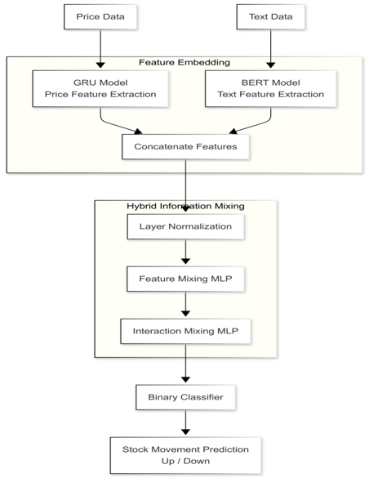

Figure 4.1.1: Overall Procedures for Hybrid Information Mixing Module

4.1.1 Feature Embedding

The feature embedding stage consists of two parallel modules: Price Embedding and Text Embedding. The price embedding module utilizes a Gated Recurrent Unit (GRU) network to extract time-series characteristics from historical stock price data. For each trading day i, five key market variables, namely opening price, high price, low price, closing price, and trading volume, are combined to form a feature vector pip_ipi​. This vector is then passed through the GRU network to generate a time-series feature representation gig_igi​, which captures temporal dependencies and sequential patterns in the stock data.

The text embedding module employs a pre-trained Bidirectional Encoder Representations from Transformers (BERT) model to process financial text data such as news articles or tweets associated with each trading day. BERT extracts contextual embeddings that capture the semantic meaning of the text. The embeddings obtained from all textual inputs for a particular day are averaged to produce a single semantic feature vector sis_isi​, representing the overall sentiment and contextual information of that day.

4.1.2 Hybrid Information Mixing Module
The hybrid information mixing module takes the mixed feature xi (created by concatenating gi and si) as input and processes it through two MLP blocks. The Feature-Mixing MLP operates on the transposed mixed feature matrix to mix channel information across different tokens, enabling global communication between different spatial locations. The Interaction-Mixing MLP operates on each row of the mixed feature to learn the correlation between embedding vectors of each feature, enabling communication between different channels. Both MLP blocks use GELU nonlinearity, skip connections, and layer normalization for training stability.

4.1.3 Binary Classifier
The output obtained from the Interaction-Mixing MLP is passed through a series of layers for final prediction. Initially, layer normalization is applied to stabilize the feature distribution, followed by a global average pooling layer that reduces the dimensionality of the feature representation. The processed features are then passed through a fully connected layer to produce the final output.
A sigmoid activation function is applied to convert the output into a probability value between 0 and 1. The model is trained using binary cross-entropy loss, which measures the difference between predicted and actual outcomes. Based on the output probability, the model classifies the stock movement as either "up" or "down" relative to the previous trading day's closing price.

4.2 USE CASE DIAGRAM
The use case diagram identifies the actors and their interactions with the system. Two primary actors are defined: Researcher/User and the Stock Prediction System. The Researcher actor can input price data, input tweet data, train the model, and evaluate predictions. The Stock Prediction System processes the inputs through GRU, BERT, MLP mixing blocks, and binary classifier to produce a stock movement prediction.
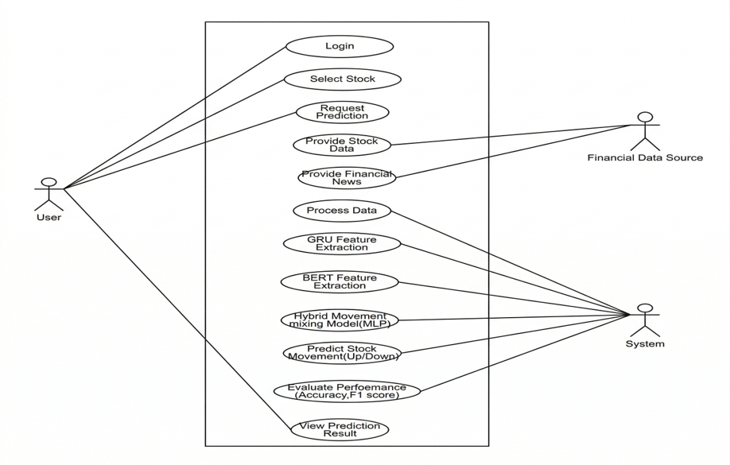

Figure 4.2.1: Use Case Diagram

4.3 ACTIVITY DIAGRAM
The activity diagram illustrates the sequential flow of operations within the Hybrid Information Mixing Module, from data input through to prediction output. The flow begins with data collection and preprocessing, followed by parallel extraction of price features via GRU and text features via BERT, feature concatenation into the mixed feature, sequential processing through Feature-Mixing MLP and Interaction-Mixing MLP, and finally binary classification to produce the stock movement prediction.

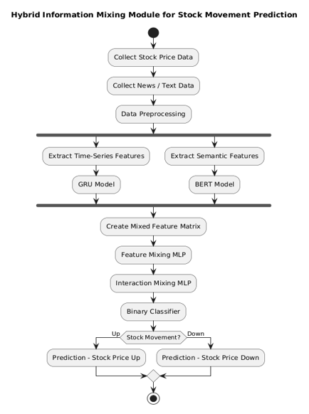

Figure 4.3.1: Activity Diagram

4.4 SEQUENCE DIAGRAM
The sequence diagram illustrates the interaction between system components during the prediction workflow. The sequence begins with the user providing price data and tweet data to the system. The price data is processed by the GRU encoder to produce gi. The tweet data is processed by the BERT encoder to produce si. These features are concatenated into xi, which is passed through the Feature-Mixing MLP and Interaction-Mixing MLP to produce xinteraction. The binary classifier then outputs the prediction.

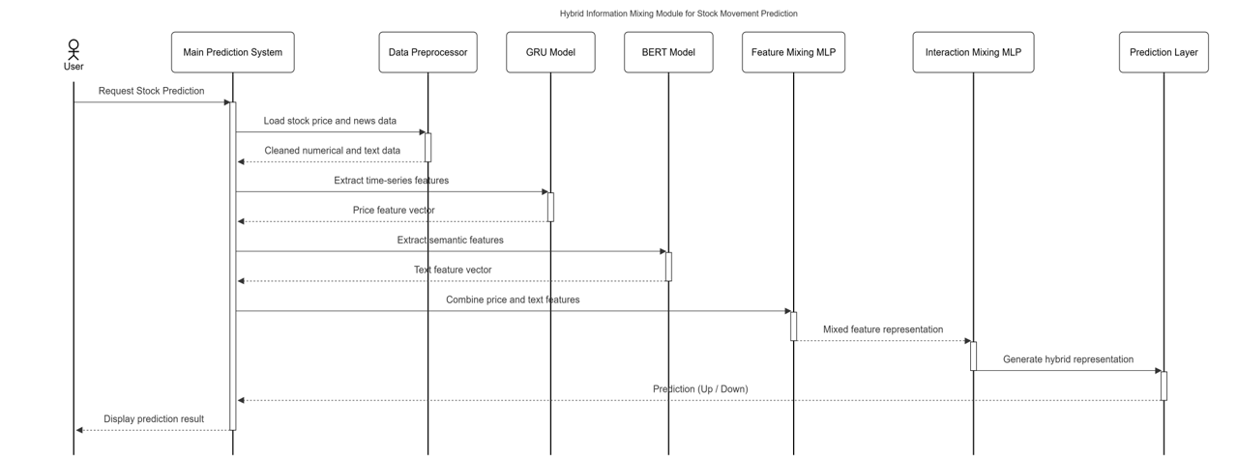

Figure 4.4.1: Sequence Diagram

4.5 CLASS DIAGRAM
The class diagram models the key entities and their relationships within the system. The main classes are: PriceEmbedder (wraps GRU for price feature extraction), TextEmbedder (wraps BERT for tweet feature extraction), FeatureMixingMLP (implements row-wise MLP block), InteractionMixingMLP (implements column-wise MLP block), HybridMixingModule (combines both MLP blocks), and BinaryClassifier (wraps the full pipeline with the output layer).

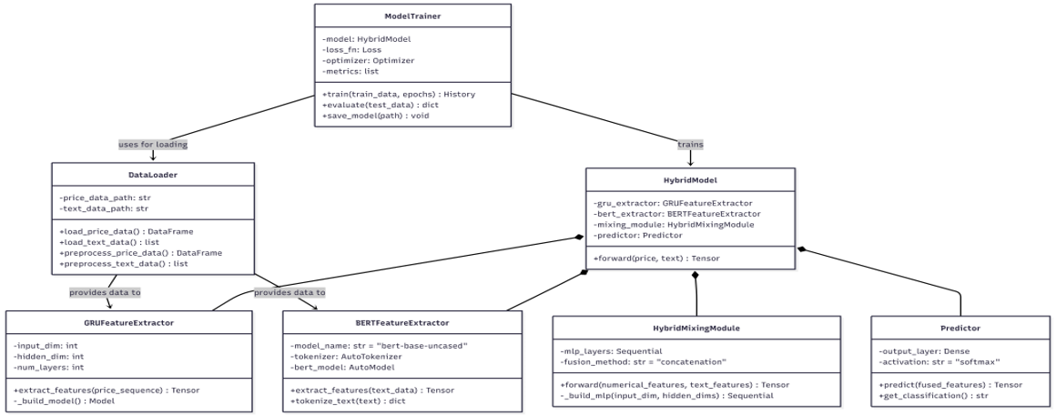

Figure 4.5.1: Class Diagram

4.6 DEPLOYMENT DIAGRAM
The deployment diagram shows the physical architecture of the system. The training node consists of a high-performance GPU server running the Python training pipeline. The data storage node contains the Stock Net dataset with historical price CSV files and tweet JSON files. The model artifact node stores trained model checkpoints. The evaluation node runs the inference pipeline on the test set to produce performance metrics.

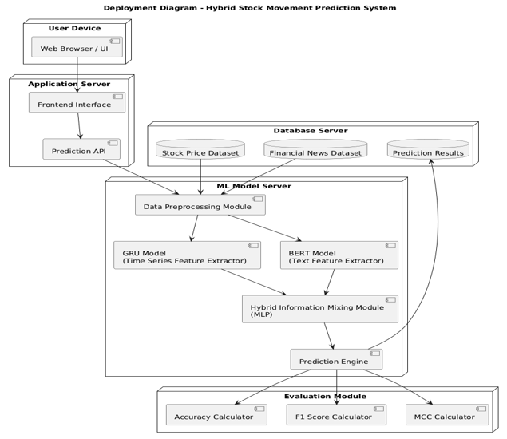

Figure 4.6.1: Deployment Diagram

4.7 SYSTEM ARCHITECTURE
The system architecture of the Hybrid Information Mixing Module follows a pipeline structure. The data layer contains the StockNet dataset with historical price data and Twitter data. The feature extraction layer runs parallel GRU and BERT encoders to produce price and text features. The feature fusion layer concatenates the features into a mixed feature matrix. The mixing layer applies the Feature-Mixing MLP and Interaction-Mixing MLP sequentially. The classification layer produces the final binary prediction using a sigmoid-activated fully connected layer.

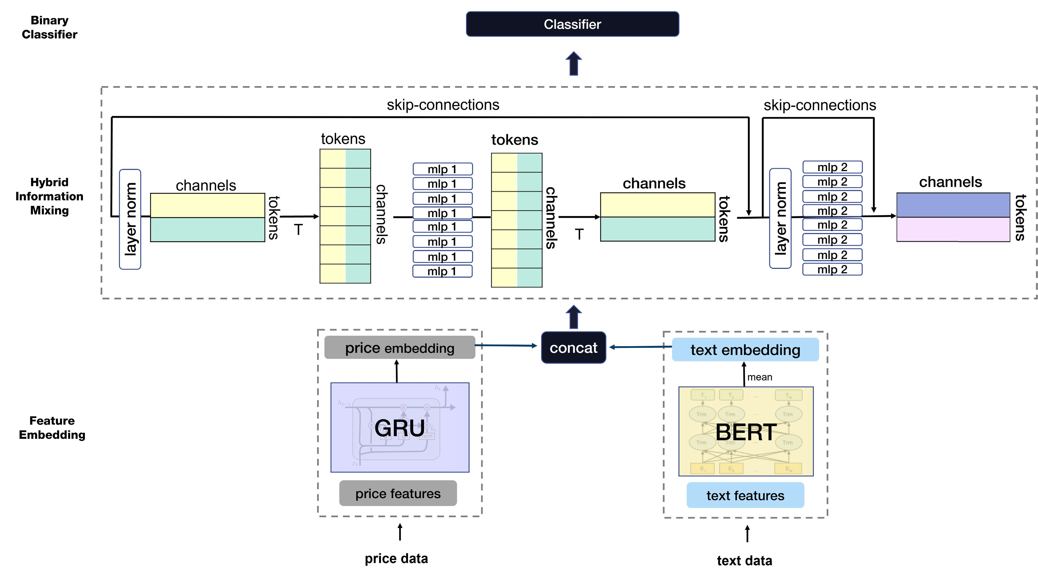

Figure 4.7.1: System Architecture Diagram

4.8 TECHNOLOGY DESCRIPTION
- Python 3.8+: Core programming language for implementing the entire pipeline, including data preprocessing, model definition, training, and evaluation.
- PyTorch: Deep learning framework used to implement GRU, MLP blocks, and the binary classifier. Supports automatic differentiation and GPU acceleration.
- GRU (Gated Recurrent Units): An RNN variant used for extracting time-series features from historical stock price data. GRU reduces LSTM complexity while maintaining similar performance.
- BERT (Bidirectional Encoder Representations from Transformers): A pre-trained transformer model used to extract contextual word embeddings from financial tweets, capturing rich semantic information.
- HuggingFace Transformers: Python library used to load and apply pre-trained BERT models with minimal configuration.
- MLP (Multilayer Perceptron): The core architectural component of the hybrid mixing module, consisting of fully connected layers with GELU nonlinearity, skip connections, and layer normalization.
- AdamW Optimizer: An adaptive optimization algorithm used for training the model, with learning rate 2e-5 and epsilon 1e-8.
- StockNet Dataset: The benchmark dataset used for training and evaluation, comprising 503 trading days of S&P 500 price data and Twitter data for 85 companies from January 2014 to January 2016.

CHAPTER 5

IMPLEMENTATION
This chapter describes the implementation of the Hybrid Information Mixing Module in detail, covering the dataset preparation, training setup, and the logic behind each major component. The implementation follows the design described in Chapter 4.

5.1 DATASET
The Stock Net dataset is used for training and evaluation. It contains historical price data for 85 companies from the S&P 500 index of the NYSE and NASDAQ markets, covering 503 trading days from January 1, 2014 to January 1, 2016. The price data includes five market variables (opening, high, low, closing prices, and trading volume) for each trading day. The tweet data contains tweets for each company, extracted using NASDAQ ticker symbols such as $GOOG.

Data preprocessing steps include removing samples that lack price data or tweets, setting a window size of 30 trading days to predict the next-day stock movement, and splitting the dataset into training (80%) and validation (20%) sets. The label for each sample is set by comparing the closing price of the target day with the previous day: label 1 (up) if the closing price is higher or equal, and label 0 (down) otherwise.

5.2 TRAINING SETUP
The following hyperparameters were used in the training setup:

Table 5.2.1: Training Hyperparameters
Hyperparameter | Value
GRU Hidden Dimension | 768
GRU Number of Layers | 4
BERT Hidden Dimension | 768
MLP Hidden Dimension | 768
MLP Number of Layers | 8
Window Size | 30 trading days
Batch Size | 32
Optimizer | AdamW
Learning Rate | 2e-5
Epsilon (AdamW) | 1e-8
GPU | NVIDIA GeForce RTX 3090

5.3 GRU-BASED PRICE EMBEDDING MODULE
The price embedding module uses a GRU network to extract time-series characteristics from historical stock price data. For each trading day i, the five market variables are concatenated into a vector pi. The GRU processes the sequence of trading days and outputs a hidden state gi, which serves as the time-series feature for that day. The GRU is configured with a hidden dimension of 768 and 4 layers, trained end-to-end with the rest of the model.

The key equations for price embedding are:
pi = [p_open_i, p_high_i, p_low_i, p_close_i, p_volume_i]
gi = GRU_p(pi, h_{i-1}), t - T <= i <= t - 1

5.4 BERT-BASED TEXT EMBEDDING MODULE
The text embedding module applies a pre-trained BERT model to all tweets uploaded on each trading day. All tweets [t1, t2, ..., tN] for each company on trading day i are processed by BERT to extract contextual word embeddings [e1, e2, ..., eN]. The embeddings of all tweets for a given day are averaged to produce a single semantic feature vector si, which serves as the text representation for that trading day.

The key equations for text embedding are:
e_v = BERT_s(t_v), v in [1, N]
s_i = (1/N) * sum(e_v for v=1 to N)

5.5 MIXED FEATURE CONSTRUCTION
After extracting the time-series feature gi and the semantic feature si, the two features are concatenated to form the mixed feature xi. The mixed feature xi is a fixed-dimensional matrix of shape F x dF, where F is the number of features and dF is the hidden dimension. This concatenation creates a multimodal representation that combines both numerical and textual market signals.

xi = CONCAT(gi, si)

5.6 FEATURE-MIXING MLP
The Feature-Mixing MLP operates on the transposed mixed feature matrix xT_i (shape: dF x F). Each token is processed by the same MLP with shared weights across all columns of the input matrix. This operation mixes channel information across different tokens, enabling global communication between different spatial locations in the feature matrix. The MLP block consists of a fully connected layer, GELU nonlinearity, and a second fully connected layer, with skip connections and layer normalization.

xFeature = xi + W2(GELU(W1(LayerNorm(xi)^T)))^T

5.7 INTERACTION-MIXING MLP
The Interaction-Mixing MLP operates on each row of the mixed feature matrix (shape: F x dF). It acts on each token independently and uses individual rows of xFeature as input, enabling communication between different channels. This operation mixes the embedding vectors of each feature, allowing the model to learn correlations between the time-series and semantic embedding dimensions.

xinteraction = xFeature + W4(GELU(W3(LayerNorm(xFeature))))

5.8 BINARY CLASSIFIER AND LOSS FUNCTION
The output xinteraction from the Interaction-Mixing MLP is passed through layer normalization, a global average pooling (GAP) layer, and a fully connected output layer. The sigmoid function converts the output to a probability. The training label is set by comparing the closing price of the target day with the previous day's closing price. Binary cross-entropy loss is used as the training objective.

xnorm = LayerNorm(xinteraction)
xGAP = GAP(xnorm)
xoutput = FC(xGAP)
y_hat = sigmoid(xoutput)
BCELoss(y_hat, y) = -[y * log(y_hat) + (1-y) * log(1-y_hat)]
5.9 SCREENSHOTS
5.9.1 Home Page

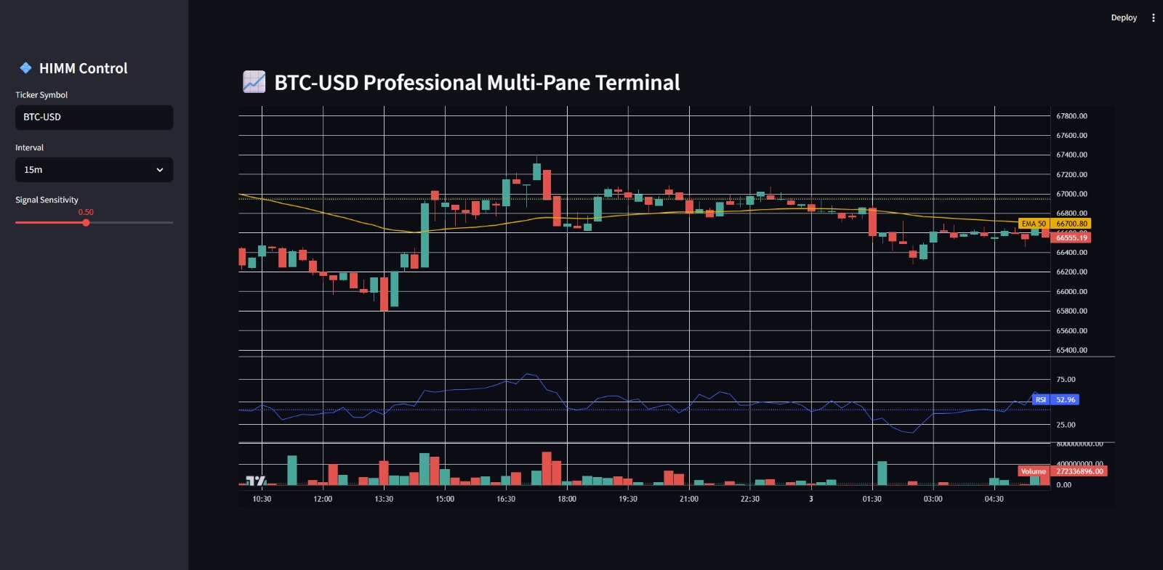

5.9.2 Prediction Page

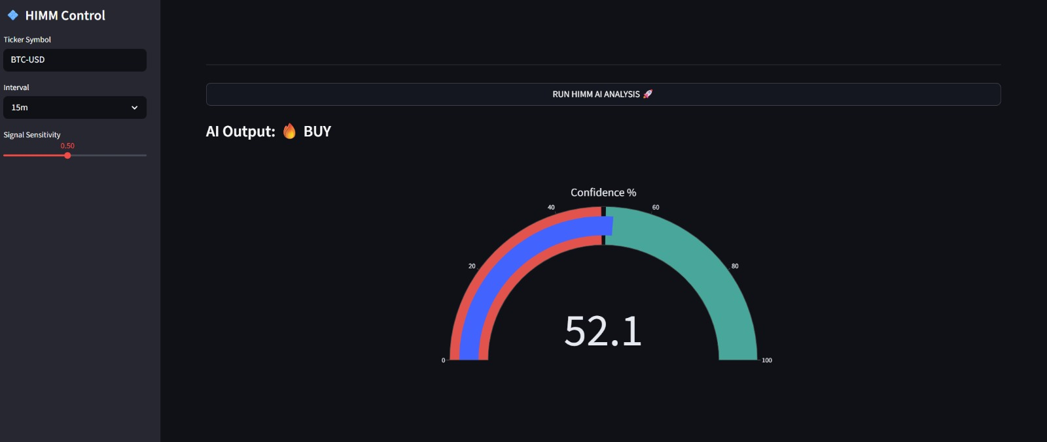

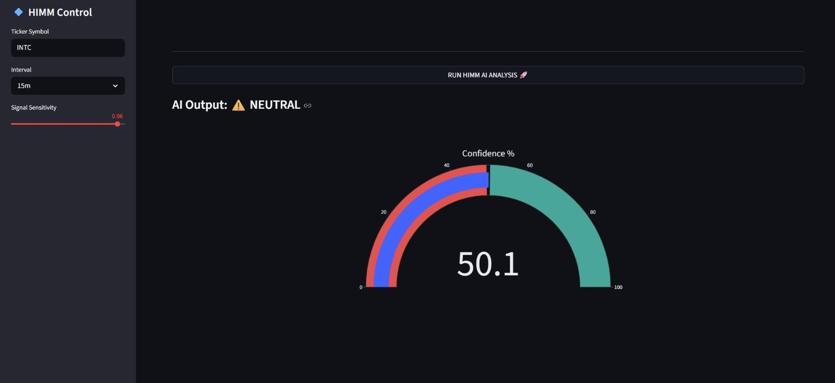

CHAPTER 6

TESTING
This chapter covers the testing and evaluation phase of the Hybrid Information Mixing Module. Experiments were conducted on the Stock Net dataset to verify that the proposed model outperforms baseline methods and to validate the contribution of each component through ablation studies.

6.1 EVALUATION METRICS
The following evaluation metrics were used, based on the confusion matrix (TP, TN, FP, FN):
- Accuracy: (TP + TN) / (TP + TN + FP + FN) — overall correct prediction rate.
- Precision: TP / (TP + FP) — proportion of predicted "up" movements that are correct.
- Recall: TP / (TP + FN) — proportion of actual "up" movements correctly predicted.
- Specificity: TN / (FP + TN) — proportion of actual "down" movements correctly predicted.
- F1 Score: 2 * Precision * Recall / (Precision + Recall) — harmonic mean of precision and recall.
- MCC (Matthews Correlation Coefficient): A balanced metric that accounts for all four confusion matrix values, providing a reliable measure even with imbalanced classes.

6.2 RESULTS OF STOCK MOVEMENT PREDICTION
A comparative experiment was conducted with LSTM, GRU, and Transformer Encoder baseline models to evaluate the performance of the Hybrid Information Mixing Module.

Table 6.2.1: Comparison of Information Mixing Methods
Model | Acc. (%) | Precision (%) | Recall (%) | Specificity (%) | F1 Score (%) | MCC
Long Short-Term Memory | 53.53 | 53.29 | 93.49 | 11.17 | 67.89 | 0.08
Gated Recurrent Units | 53.02 | 52.80 | 86.78 | 16.82 | 65.66 | 0.05
Transformer Encoder | 51.61 | 51.56 | 98.96 | 1.38 | 67.79 | 0.01
Hybrid Information Mixing Module (Ours) | 69.20 | 63.49 | 95.19 | 41.37 | 76.17 | 0.43

The Hybrid Information Mixing Module achieves the best performance with 69.20% accuracy, MCC of 0.43, and F1 score of 76.17%. This improves accuracy by approximately 15.67% over LSTM and 16.18% over GRU. The results confirm that the two MLP blocks effectively mix multimodal information to capture market signals for stock movement prediction.

6.3 ABLATION STUDY
An ablation study was conducted to compare the performance of GRU and LSTM for price embedding within the proposed system.

Table 6.3.1: Comparison of Price Embedding Methods
Model | Acc. (%) | Precision (%) | Recall (%) | Specificity (%) | F1 Score (%) | MCC
Long Short-Term Memory | 68.53 | 63.21 | 94.42 | 40.49 | 75.73 | 0.41
Gated Recurrent Units | 69.20 | 63.49 | 95.19 | 41.37 | 76.17 | 0.43

The results show that GRU slightly outperforms LSTM across all metrics. GRU is better suited for this task due to its fewer parameters and simpler structure, which is advantageous when the dataset size is not very large. Therefore, GRU is used as the price embedding method in the final model.

CHAPTER 7

CONCLUSION AND FUTURE SCOPE

7.1 CONCLUSION
The Hybrid Information Mixing Module for Stock Movement Prediction has been successfully designed, implemented, and evaluated on the StockNet benchmark dataset. The system effectively integrates time-series price features extracted by GRU and semantic text features extracted by BERT through a novel dual MLP mixing architecture, achieving superior performance compared to LSTM, GRU, and Transformer baseline models.

The proposed model achieves 69.20% accuracy, an MCC of 0.43, and an F1 score of 76.17% on the Stock Net dataset, representing improvements of approximately 15.67% in accuracy and 0.35 in MCC over LSTM, and 16.18% in accuracy and 0.38 in MCC over GRU. The Feature-Mixing MLP enables global communication between different tokens in the mixed feature, while the Interaction-Mixing MLP enables communication between different channels, together enabling effective multimodal interaction.

The success of this project demonstrates that a simple MLP-based architecture, when designed with careful attention to multimodal feature interaction, can outperform more complex transformer-based models in the stock movement prediction task. The modular architecture of the system ensures it can be extended with additional data modalities and improved mixing strategies in future work.

7.2 FUTURE SCOPE
The following enhancements are planned for future iterations of the Hybrid Information Mixing Module:
- Company Relationship Data: Incorporate company relationship graphs to capture inter-company influence patterns, extending the multimodal information to three types: price, text, and company relationships.
- Extended Social Media Sources: Include additional text data sources such as news articles, Reddit discussions, and earnings call transcripts to enrich the semantic feature representation.
- High-Volatility Period Testing: Test the model specifically on high-volatility periods such as the COVID-19 pandemic to evaluate robustness under extreme market conditions.
- Graph-Based Models: Explore graph neural network architectures to model the dynamic inter-stock correlations and sector-level influences on stock price movements.
- Real-Time Prediction System: Deploy the trained model as a real-time prediction API that ingests live price feeds and news streams to generate continuous stock movement predictions.
- Cross-Validation: Implement k-fold cross-validation to provide more robust performance estimates and reduce variance in evaluation results.
- Multi-Market Extension: Extend the system beyond the US market (NYSE/NASDAQ) to include international stock markets such as NSE, BSE, and LSE.

REFERENCES

[1] Y. Xu and S. B. Cohen, "Stock movement prediction from tweets and historical prices," in Proc. 56th Annual Meeting Assoc. Comput. Linguistics, Melbourne, VIC, Australia, 2018, pp. 1970-1979.
[2] J. Choi, S. Yoo, X. Zhou, and Y. Kim, "Hybrid Information Mixing Module for Stock Movement Prediction," IEEE Access, vol. 11, pp. 28781-28790, 2023.
[3] K. Cho, B. van Merrienboer, C. Gulcehre, D. Bahdanau, F. Bougares, H. Schwenk, and Y. Bengio, "Learning phrase representations using RNN encoder-decoder for statistical machine translation," in Proc. EMNLP, 2014, pp. 1724-1734.
[4] J. Devlin, M.-W. Chang, K. Lee, and K. Toutanova, "BERT: Pre-training of deep bidirectional transformers for language understanding," in Proc. NAACL-HLT, 2019, pp. 4171-4186.
[5] R. Sawhney, S. Agarwal, A. Wadhwa, and R. R. Shah, "Deep attentive learning for stock movement prediction from social media text and company correlations," in Proc. EMNLP, 2020, pp. 8415-8426.
[6] I. Tolstikhin et al., "MLP-Mixer: An all-MLP architecture for vision," in Proc. NeurIPS, vol. 34, 2021, pp. 24261-24272.
[7] Y. Zhao et al., "Stock movement prediction based on bi-typed hybrid-relational market knowledge graph via dual attention networks," arXiv:2201.04965, 2022.
[8] J. Yoo, Y. Soun, Y.-C. Park, and U. Kang, "Accurate multivariate stock movement prediction via data-axis transformer with multi-level contexts," in Proc. ACM SIGKDD, 2021, pp. 2037-2045.
[9] S. Hochreiter and J. Schmidhuber, "Long short-term memory," Neural Computation, vol. 9, no. 8, pp. 1735-1780, 1997.
[10] A. Vaswani et al., "Attention is all you need," in Proc. NeurIPS, 2017, pp. 5998-6008.

